Code Source

Ai Question
# Source: Provided by [Motasem Essam -> motasem.essam.prototypedoteg.com@gmail.com] on [11/17/2025]
# Data Path: Entities Folder -> Entities Database -> Persons Table -> ID: 1
give me python code to get names of each file with extension in specific folder give me way to select folder by window and

Ai Answer
# Source: Chatgpt (GPT‑5 Mini) at [11/17/2025]
Here is a simple and clean way to pick a folder using a Windows dialog and then list all files with their extensions inside that folder.
✅ Option 1 — tkinter (built-in, easiest)
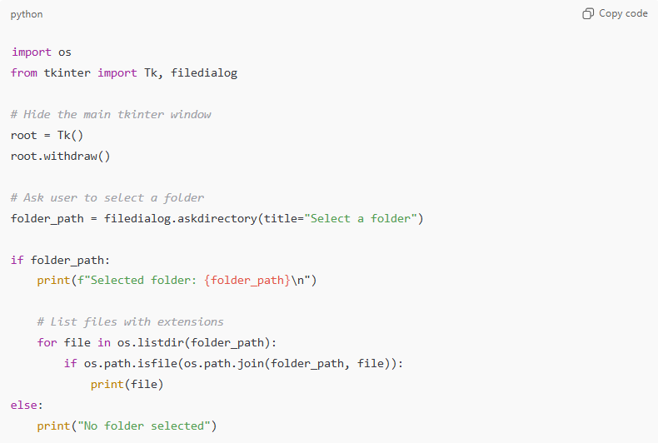
import os
from tkinter import Tk, filedialog

# Hide the main tkinter window
root = Tk()
root.withdraw()

# Ask user to select a folder
folder_path = filedialog.askdirectory(title="Select a folder")

if folder_path:
print(f"Selected folder: {folder_path}\n")

# List files with extensions
for file in os.listdir(folder_path):
if os.path.isfile(os.path.join(folder_path, file)):
print(file)
else:
print("No folder selected")

✅ Option 2 — If you want only files with a specific extension
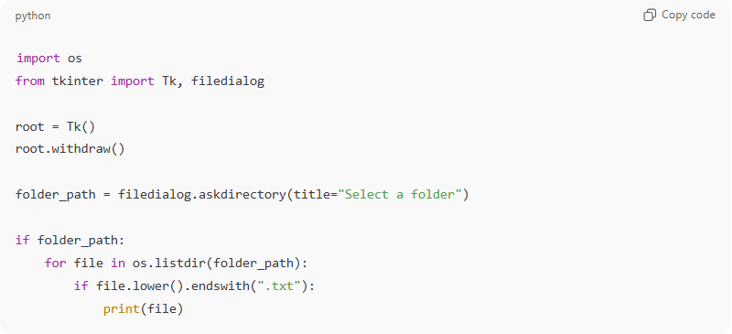
Example: only .txt files.
import os
from tkinter import Tk, filedialog

root = Tk()
root.withdraw()

folder_path = filedialog.askdirectory(title="Select a folder")

if folder_path:
for file in os.listdir(folder_path):
if file.lower().endswith(".txt"):
print(file)

💡 How it works
- filedialog.askdirectory() opens a Windows folder-selection dialog
- os.listdir() gives all items inside the folder
- os.path.isfile() ensures we only print files
- prints full filenames with extensions

If you want, I can also:
✔ return full file paths
✔ recursively list files in all subfolders
✔ filter by multiple extensions
✔ export the list to a CSV or text file
Just tell me!

Ai Question
# Source: Provided by [Motasem Essam -> motasem.essam.prototypedoteg.com@gmail.com] on [11/17/2025]
# Data Path: Entities Folder -> Entities Database -> Persons Table -> ID: 1
how to run python

Ai Answer
# Source: Chatgpt (GPT‑5 Mini) at [11/17/2025]
Here are the simplest ways to run Python, depending on what you prefer.
Choose the one that matches how you want to work:

✅ 1. Run Python from a .py file (most common)
Steps:
- Open Notepad, VS Code, or any editor.
- Save your code as:
your_script.py
- Open Command Prompt (Win + R → type cmd).
- Type:
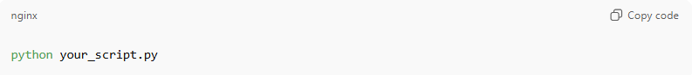
python your_script.py
If your system uses python3, then:
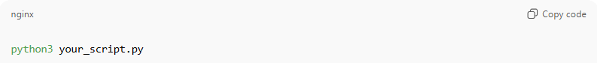
python3 your_script.py

✅ 2. Run Python from IDLE (comes with Python)
- Install Python from python.org
- Open IDLE (it installs automatically)
- You can:
  - type code directly and press Enter
  - or open a file → Run → Run Module (F5)

✅ 3. Run Python in VS Code
- Install Visual Studio Code
- Install Python extension
- Open your .py file
- Press Run ▶ in top-right
or F5

✅ 4. Run Python from Windows PowerShell
Open PowerShell and run:
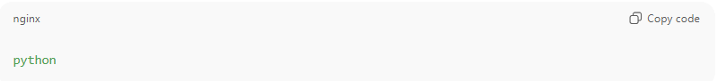
python
(or python3)
You can also run a file:
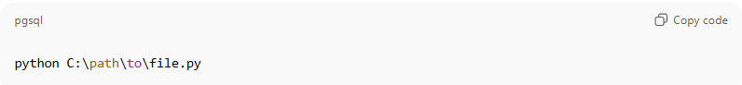
python C:\path\to\file.py

💡 Check if Python is installed
In Command Prompt:
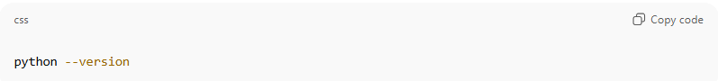
python --version
If it prints something like Python 3.11.3, you're good.

If you want, tell me:
- Your Windows version, and
- How you prefer to run code
…and I’ll guide you step-by-step perfectly for your setup.

